TOPIC: Home Automation with sensors,button and LED NAME: KEERTHANA M

911519106008

It's a home automation system where

1. The door will open if anyone comes near the door within 40cm and the door will be open for 2 seconds. Then it will check again if anyone is still within 40cm, if yes, then the door will still open for 2 more seconds and if no, then the door will automatically be closed. ( I used here Ultrasonic Sensor for measuring distance and Servo motor for opening the door )
2. If the room detects any movement, the light (LED) will automatically be lighting. If there is no movement in the room, then the light will remain off. ( I used here PIR for detecting movement and LED for Light )
3. It will detect room temperature and if that is greater than 20 (degree Celsius) then a fan will be running, otherwise, the fan will remain stopped. (I used here temperature sensor LM35 for detecting temperature and a motor for running a fan)

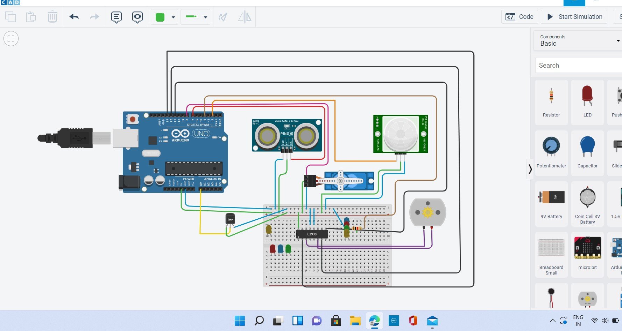

|  |
| --- |
| 1. #include<Servo.h> 2. const int pingPin = 7; 3. int servoPin = 8;   4  5 Servo servo1;  6   1. void setup() { 2. // initialize serial communication: 3. Serial.begin(9600); 4. servo1.attach(servoPin); 5. pinMode(2,INPUT); 6. pinMode(4,OUTPUT); 7. pinMode(11,OUTPUT); 8. pinMode(12,OUTPUT); 9. pinMode(13,OUTPUT); 10. pinMode(A0,INPUT); 11. digitalWrite(2,LOW); 12. digitalWrite(11,HIGH); 13. }   20   1. void loop() { 2. long duration, inches, cm;   23   1. pinMode(pingPin, OUTPUT); 2. digitalWrite(pingPin, LOW); 3. delayMicroseconds(2); 4. digitalWrite(pingPin, HIGH); 5. delayMicroseconds(5); 6. digitalWrite(pingPin, LOW);   30   1. // The same pin is used to read the signal from the PING))): a HIGH pulse 2. // whose duration is the time (in microseconds) from the sending of the ping |

|  |
| --- |
| 1. // to the reception of its echo off of an object. 2. pinMode(pingPin, INPUT); 3. duration = pulseIn(pingPin, HIGH);   36   1. // convert the time into a distance 2. inches = microsecondsToInches(duration); 3. cm = microsecondsToCentimeters(duration);   40   1. //Serial.print(inches); 2. //Serial.print("in, "); 3. //Serial.print(cm); 4. //Serial.print("cm"); 5. //Serial.println(); 6. //delay(100); 7. servo1.write(0); 8. if(cm < 40) 9. { 10. servo1.write(90); 11. delay(2000); 12. } 13. else 14. { 15. servo1.write(0); 16. } 17. // PIR with LED starts 18. int pir = digitalRead(2); 19. if(pir == HIGH) 20. { 21. digitalWrite(4,HIGH); 22. delay(1000); 23. } 24. else if(pir == LOW) |
| 1. { 2. digitalWrite(4,LOW); 3. } 4. //temp with fan 5. float value=analogRead(A0); 6. float temperature=value*0.48; 7. Serial.println("temperature"); 8. Serial.println(temperature); 9. if(temperature > 20) 10. { 11. digitalWrite(12,HIGH); 12. digitalWrite(13,LOW); 13. } 14. else 15. { 16. digitalWrite(12,LOW); 81 digitalWrite(13,LOW); 17. } 18. }   84   1. long microsecondsToInches(long microseconds) { 2. return microseconds / 74 / 2; 3. }   88  89 long microsecondsToCentimeters(long microseconds) { 90 return microseconds / 29 / 2;  91 } |